|  |  |
| --- | --- |
| *Coursework Header Sheet* 213106-91  https://nelson.gre.ac.uk/gengifs/uog_barcodex.gif 2 1 3 1 0 6 9 1 https://nelson.gre.ac.uk/gengifs/uog_barcodex.gif | https://nelson.gre.ac.uk/gengifs/uog_logo.jpg |

|  |  |  |  |
| --- | --- | --- | --- |
| Course | BUSI1359: Pathway Specialisation Project | Course School/Level | BU/PG |
| Coursework | Dissertation | Assessment Weight | 0.00% |
| Tutor | AC Van Klyton | Submission Deadline | 30/01/2014 |

|  |
| --- |
| Coursework is receipted on the understanding that it is the student's own work and that it has not, in whole or part, been presented elsewhere for assessment. Where material has been used from other sources it has been properly acknowledged in accordance with the University's Regulations regarding Cheating and Plagiarism. |

000756291    https://nelson.gre.ac.uk/gengifs/uog_barcodex.gif 0 0 0 7 5 6 2 9 1 https://nelson.gre.ac.uk/gengifs/uog_barcodex.gif    Linakar Sri Perumbudur

|  |  |  |  |  |
| --- | --- | --- | --- | --- |
| *Tutor's comments* | | | | |
| *Grade Awarded___________* | ***For Office Use Only__________*** | ***Final Grade_________*** |
| *Moderation required: yes/no* | ***Tutor______________________*** | ***Date _______________*** |

MARKETING STRATEGIES OF MERCEDES BENZ IN INDIA AND UNITED STATES

______________________________________________________________________________

|  |
| --- |
|  |

Name of the Student: Linakar Sri Perumbudur

Student Number: 000756291

Programme: MBA International Business

Name of the University: University of Greenwich, Business School

Starting Date: January 2013

Course Title: Project MBA IB

Subject Code: BUSI 1359

Name of the Supervisor: Francisca Da Gama



Abstract:

Marketing is the backbone of any organization as it provides the necessary intelligence and the consideration to the customer needs and satisfaction. The different aspects are thoroughly dependent on the marketing concepts as per the relativity of the product and the approachability to the customers. The marketing concept itself is a cluster of different functions like product, price, promotion, physical evidence, the people and also the promotion. And these functions and the marketing strategy play an important role for the multinational organization that are providing premium product with respect to the other companies such as Mercedes Benz.

The purpose of this study is to compare, analyze and classify the different marketing strategies of Mercedes Benz between the United States and India. To understand the objective, there are different research methods used as primary and secondary research and the data is analyzed and discussed. From the research an understanding is gained about the cultural, physiological and the geographical factors which will determine the different aspects of the products introduced in the different countries and the perception of the product. For this research, the data collection is an important as it is with the help of data collected would facilitate to meet with objectives of the research. The data collected and its analysis would help to establish a better understanding of the research topic.

Contents

List Of Tables 6

List Of Figures 6

Chapter 1.0 Introduction: 7

1.1Aim and Objectives: 8

1.2 Research Questions: 9

1.3 Hypothesis: 9

Chapter 2.0: Literature review: 9

2.1 Introduction: 9

2.2 Consumer Behaviour: 11

2.3 Factor that influences the Buying behaviour of Consumers: 12

2.4 Marketing across Culture: 12

2.5 Marketing strategy in USA: 13

2.6 Marketing Strategy in India: 14

2.7 Differences in the marketing strategies of Mercedes in India and USA 17

2.8 Conclusion: 18

Chapter 3.0: Research Methodology 18

3.1 Introduction 18

3.2 Research Philosophy 18

3.3Research Approach 19

3.4 Research Design 19

3.5 The Data Types 19

3.6 Sample Size 20

3.7 Research Ethics 20

Chapter 4.0 Data Analysis and Interpretation: 21

4.1 Introduction: 21

4.2 Descriptive analysis: 21

4.3 Crosstabs 23

4.4 Regression analysis: 37

4.5 Qualitative Analysis: 42

4.6 Discussion 44

Chapter 5.0: Conclusions and Recommendations 45

5.1 Introduction 45

5.2 Objectives Linking: 45

5.3 Recommendations 49

References 51

# List of Tables

Table 1Descriptive Statistics 21

Table 2 Residential Cluster 23

Table 3 Brand Vs Need Fulfilment 24

Table 4Mercedes as a Luxury Brand 26

Table 5Value For Product 28

Table 6 Mileage as an Important Feature 30

Table 7 Leasing your Mercedes 32

Table 8Financial Planes Vs Consumer Behaviour 34

Table 9 ANOVA 37

Table 10 Spearman Model 38

Table 11 Anova- Brand Vs Need Fulfilment 39

Table 12 Coefficients-1 40

Table 13 Coefficients-2 40

Table 14 Residual-1 41

# List of Figures

Figure 1Brand Value and Satisfaction 25

Figure 2Mercedes as a Luxury Brand 27

Figure 3Value For Money 29

Figure 4 Mileage as an Important Feature 31

Figure 5Leasing your Mercedes 33

Figure 6 Financial Planes Vs Consumer Behaviour 35

Figure 7 Dependent-1 41

Figure 8 Resale value 46

Figure 9 Level Of Satisfaction 47

# Chapter 1.0 Introduction:

Marketing strategy is the combination of many different factors and functions which determines the different plans and future steps for any organization. Strategies are incorporated into the process by which the company’s material, resources are utilized and attained to get the maximized profits by gaining the market share and the sales volume. All the organizations are involved in the marketing process to get the market share and presence. To attract the targeted customers, the companies need to understand the customers and their need and for that, they should carry the market research and test marketing to identify. The strategies can be made from the perfect analysis of the internal and the external factors and the strategies should address the product information such as design, aesthetics, price, packaging and also the promotional activities and the place where the product should be launched and placed.

The process of marketing does not only helps in identifying or promoting the product, but also to target the new customers and retain the old ones. From the marketing point of view, the portfolio analysis is also very important as it helps to understand the plans and actions should be taken for the products and the service. (Yaping and Jun, 2002). The marketing strategies also help the customers to stimulate the buying behaviour and the opportunities to use the product as per the need. In the automobile industry’s scenario, the market is highly competitive as there are many players and there are also more substitutes. Though the customers have the buying power, brand recognition is very much needed to get the products rolling. The business has entered into the high conditioned and high competitive stage and the marketing is the only means to rejuvenate the market segment. The automotive sector has become a quite competitive in due to the presence of so many automotive businesses and most of the companies are continuously coming up with innovative and price effective automobiles. Thus this has render most of the bigger houses to face a considerable pressure and it are due to increasing competition in the automobile market that the sustainability of the business organizations is being conditioned.

The Mercedes-Benz company is one of the finest motor companies in the world. This is a multinational company which produces luxury cars, buses, coaches and heavy vehicles. The company operates in different countries and has different subsidiaries and sister concerns such as Mercedes AMG, Mercedes Benz McLaren and Maybach. As per the marketing strategy, the USA customers are more concerned about the safety, high tech engineering and the styles. But in India, the people are also concerned about their safety however they are more inclined towards the reasonability of car price. Due to the economic difference and the price concerned of Mercedes Benz, the product is valued as a niche product. But according to the Mercedes Benz Company, the company is more focused on the personal preference of the customers. The company concentrates on the premium brand experience for the future competitive edge and the market capitalization.

The new strategy of the company is more concentrated on the customer satisfaction and the experience as the new launch of the product A class attracts the test drive of around 25000 people in European cities. (Yaping and Jun, 2002). The company also concentrates on various pop up stores and road shows to showcase the product and the digital media is used to market the product more vigorously. Online promotion, viral advertising and word of mouth are the main sources of the growing brand value of Mercedes Benz. Mercedes Benz also provides the customers to customize the product as per their need and demand. There are options in the website to interact with customers who can modify or change certain parts of the product.

The marketing strategies broadly vary with the perception of the customers as the customers can give the exact insight about the usefulness and the priority of the marketing campaigns and the activities. Also the marketing strategy includes the channel sales, the after sales service and the product orientation for the Mercedes Benz in the different countries and places. The Mercedes Benz USA (MBUSA) was founded in the year 1965 and has since, delivered extraordinary results through its extraordinary engineering, designing and innovation (Urban, G. & Hauser, J. 1980). The Mercedes Benz USA has been named as one of Fortune magazine’s 100 Best Companies to work for. The units of the Mercedes Benz Company are well known for its superb working conditions provide to its workers.

## 1.1Aim and Objectives:

The aim of this research is to uncover the differences between the marketing strategies of the Mercedes Benz in United States and India. The objectives of this study

* To evaluate the different marketing strategies of the company
* To analyse the differences between the marketing strategies of the Mercedes Benz in India and the United States
* To evaluate the reasons for the differences in the process of marketing strategies of Mercedes Benz between India and United States

## 1.2 Research Questions:

The research Questions which are to be evaluated and asked in this market research are:

* What are the marketing strategies followed by the Mercedes Benz?
* Is there, and if so why is there a difference in the strategies of the Mercedes Benz marketing done in India and United States?
* What are the basic customer’s concepts in the light of the brand recognition and the brand awareness of the Mercedes Benz?
* What factors are related to the sales of the Mercedes Benz cars and the relativity of the marketing strategies in the mind of the customer’s?

## 1.3 Hypothesis:

In order to understand the customer’s concept and the marketing activity, there is a research hypothesis which is used for the marketing strategy understanding in the quantitative research.

The Null hypothesis is that there is no significant difference in the opinions of Indian and American Mercedes Benz owners about the brand.

The alternate hypothesis is that there is significant difference in the opinions of Indian and American Mercedes Benz owners about the brand.

# Chapter 2.0: Literature review:

## 2.1 Introduction:

Mercedes Benz has been one of the most dynamic global players when it comes to the luxury cars brands. The success of the Mercedes Benz Company can be attributed to the fact that the marketing strategies of the Company are perfectly in sync with the conditions prevailing in different target destinations (Iacobucci, *et al.*, 1996). The management of the Mercedes Benz Company has played the most important role behind the success of the Company in different nations. The Mercedes Benz Company manufactures and distributes automobiles in 104 nations across the world and has 13,000 showrooms spread across the globe. In order to study and analyze the market strategy of the Mercedes Benz Company the various aspects of consumer behaviour need to be studied.

For the better understanding of the marketing strategies adopted by the Mercedes Benz Company from time to time in various business destinations the study of the concept of the four Ps is vital (Scheele, N. 1995). The four Ps stand for product, price, promotion and place or distribution. The concept of the four Ps stands vital in the formulation and implementation of any marketing strategy. Any Company needs to conduct a vivid study on these vital aspects of marketing strategy for a successful business endeavour. The application of the concept of four Ps in the marketing strategy of the Mercedes Benz Company can be understood by the following analysis:

In the context of the product, the features of the products have shown differences in the case of India and USA. The focus of the product in India was on the price consideration and affordability and involved the processes to make the product more user-friendly and energy efficient. In the case of the USA the focus of the product was to provide the customers with high standards pertaining to the design, technology and the comfort and pleasure level (Scheele, N. 1995).

In the context of price, in India the focus was to cut down the costs involved in the production and transportation process and thereby offer affordable prices without compromising on the quality. This is absolutely vital to maintain the competitive edge over the rivals which are increasing at an alarming rate. In the case of the USA, the target customer base was the high-income groups of the society to who the clauses of design and comfort were of particular concern. Thus, the price consideration and affordability are less important than design, technology and pleasure. The company has to ensure that under no circumstances the quality of the product falls failing which it would lose its customer base to the array of other global competitors like BMW, Audi and Bentley (Sanyanusin, 1994).

In the context of promotion, the Mercedes Benz Company has adopted a number of steps to promote its products in a way so as to appeal to the various segments of the customers in the most effective way. The promotion strategy involves the advertisement in the newspapers, popular magazines, journals and prominent presence in the internet platform and in social networking sites. The Mercedes Benz Company lays special emphasis on the customer care service and provides for an emergency customer care facility. It also has an online interactive communication system with the customers-both existing and potential- and seeks to provide information and clear doubts regarding any issue (Sanyanusin, 1994).

The factor of place or distribution is of particular importance when it comes to identifying the differences in the market strategies in the USA and India. In this context, the identification of the market segments is vital. In India the products are mainly meant to address the needs of the high-income and upper middle-class group residing in the metropolitan cities. The market in the USA has also been fragmented based on the age, economic conditions and tastes and preferences of the customers in each segment and the products-the price and their distribution- and ultimately, the marketing strategy is based in the identification of the needs and expectations of each segment.

### 2.2 Consumer Behaviour:

The study of consumer behaviour is the study of a blend “of the elements of psychology, sociology, social anthropology and economics “(Howard and Sheth, 1968). It is concerned with the study of the decision-making process of the consumers and the behavioural trends that influence the buying habits of the consumers. The consumer behaviour is studied in relation to the different changes in the market conditions and how those conditions shape the buying pattern of the consumers. The consumer behaviour depends on the goods and services available in the market in a specific period of time and the prices of the products and the other alternatives available in the market and how the consumers behave in relation to the existing scenario and as a result of the changes that take place in the market from time to time. The tastes and preferences, the social and cultural background and the price-affordability of the consumers are the important factors that shape the kind of behaviour certain segments of consumers or certain consumers show in the market. In a nutshell, consumer behaviour can be defined as “the decision making process and physical activity involved in acquiring, evaluating, using and disposing of the goods and services*”* (Loudon, 1988).

### 2.3 Factor that influences the Buying behaviour of Consumers:

The buying decision of the consumers with regard to cars is based on the consideration of these factors. The price of the product is one of the most important factors that influence the buying decisions of the consumers. It is always desirable from the consumers end that they prefer the most price effective automotive products. Another significant factor is the income of the consumers it is based on the income of consumers that determines the living standard of the people and the society on the whole. The affordability of the consumers depends on their income level thus it is another concern for the business organizations that pricing of the products should be done in such a way which would be affordable for most number of buyers. The features of the cars along with the money that the consumers are ready to pay are another very important consideration that influences the buying behaviour of consumers. Among all the internal and external features of cars including design the safety factor can be said to be the most important one as along with a use of cars the safety is a major concern for the entire consumer groups.

### 2.4 Marketing across Culture:

The selection of suitable strategies for marketing across culture is one of the main concerns for the multinational business houses. For the purpose to augment revenue and the profitability of business the business houses are not only concerned about selection of proficient strategies. At the same time business houses must have through understanding of cross cultural aspect that would enable them implement better marketing strategies for a better hold in the international markets. The concept of marketing across culture determines that how incorporates and at the same time understand international diversity. It is owing to the fact that the global business environment in getting increasingly interconnected and getting all the more competitive. Therefore it has become very important for the business organizations to understand the cultural differences and its influence on the overall performance of the business. The cross cultural approach has added a new dimension to the business management as it can directly impact on the revenue generation and sustainability of the business houses. It is adaptation of different cultures by the business organizations and implementing the effect of the different cultures to derive better revenue from the formulation of business is defined as marketing through the cross cultural activities from business prospective (Hutt, *et al.,* 1995).

## 2.5 Marketing strategy in USA:

The marketing strategy of the Company in the USA has been is quite instrumental to achieve a better profitability by the businesses in this automobile sector. The conditions prevailing in the country and as such, the company has been able to address the needs and expectations of the customers in the USA (Motor Industry and Research Association 1997). The strategy of the Mercedes Benz has been highly responsive to the changes the market conditions and the customer behaviour have experienced over the time. At the outset, the strategy and the plan for the development of the business in the USA was emphasized on the safety and the luxury quotient. The policies of marketing and promotion were based on this very criterion. The Company was successful in experiencing a high magnitude of sales and was able to create a strong customer base and an esteemed corporate image. However, with the progress of time and other developments in the market scenario and considerable changes in the behaviour of the customers the marketing strategy of the Mercedes Benz Company had to be changed. This phenomenon is attributed to the entry of several other global automobile manufacturers into the market of the USA. Thus, the customers got an array of options to choose from and the hegemony of the Mercedes Benz in the luxury car sector came to an end. In response to these changes, the marketing strategy of the Mercedes Benz Company changed and the emphasis shifted from the safety clause and the luxury quotient to the aspects of the tastes and preferences and the lifestyle of the customers and the development and the implementation of the plans according to the present market conditions and the customer behaviour. The cars have been made approachable to the people, meaning that the spectrum of the target customers have become larger. The policies and plans are aimed towards the fulfilment of the expectations of the people and thus have experienced a price-cut and more emphasis has been laid on the fun-loving or the adventurous clause (Motor Industry and Research Association 1997). The cars thus launched have been designed to suit the needs and expectations of the different segments existing in the US market on the basis of age, economic conditions and cultural background. The Mercedes Benz Company has launched cars meant for the young and the adventurous as well as the aged and the comfort- seeking. Thus the marketing strategy of the Mercedes Benz Company has increased in its platform and appeal and have increased the base of its target customers from being confined to the high-income elites to the middle-income group as well. Moreover, the Company has put emphasis on the after-purchase services like a sound and effective customer care service. This is aimed to create and maintain a good corporate image and hence, maintain a strong customer base. The Mercedes Benz Company’s US strategy is based on what is termed as a Customer Value Triad. The Customer Value Triad is comprised of the three clauses:

Perceived quality of the goods,

Service quality; and

The value-based prices

The marketing strategy of the Mercedes Benz Company in the USA has been mainly concerned about the clauses of comfort, pleasure, design and technology. It involves the steps taken to improve the production both-qualitatively and quantitatively- and to incorporate new innovative ideas to address the evolving needs of the consumers from time to time in order to have an upper hand over the rivals and maintain a place of esteem in the highly competitive market (Hoyer, & Brown, 1990).

## 2.6 Marketing Strategy in India:

India’s market for luxury cars are the fastest growing segment and has shown a considerable growth as per the reports of automobile industry in India. As one of the fastest growing economies of the world, India provides for a lucrative hub for the global players of the West and the East. The consistent growth rate of 8-9% for more than five years and the increase in the per capita disposable income and the growing entrepreneur class in India have made the market for the luxury cars healthy and highly progressive (Marquardt, S 1994). The main two factors responsible for the glory in the automobile market are as follows:

Increase in disposable incomes and the rise in living standards of the middle-class families in India who number as many as four million.

The steps taken by the government of India such as the relaxation of the foreign exchange and equity regulations, considerable cuts in the tariffs on imports and liberalization on the banking sector have been a vital force behind the growth and progress of the automobile industry.

The Mercedes Benz Company in India has also been subject to considerable changes over the years owing to different factors in the market environment as well as in the customer behaviour. The main factors that have its influence on the buying behaviour of the consumers are the price, income standard, safety measures and the futures and design of the car and so on. However, the case study of India shows a different set of factors influencing the marketing strategy of the Mercedes Benz Company in India. The situations in India vary from the situations in the USA and as such the consumer behaviour also shows different trends and thus, the marketing strategy adopted by the Mercedes Benz Company is different from that in the USA from time to time. The Mercedes Benz India Pvt. Ltd. is a subsidiary fully owned by the German Daimler AG and was founded in the year 1994. The headquarters is situated in the city of Pune in the state of Maharashtra. The Mercedes Benz Company listed in the top 100 most trusted companies in India on a report published by The Brand Trust Report. It also won the distinction of being the winner of the prestigious Best Brand Award by Auto India Best Brand Awards in the year 2011.the Mercedes Benz Company has a commercial vehicle plant in the outskirts if the city of Chennai and the Company is currently upgrading the facility with an investment of 700 million Euros. The Company has also established a car manufacturing plant in the city of Pune and the largest research and development facility of its company outside Germany in the city of Bangalore on the state of Karnataka in the year 1996.

Recently, the Mercedes Benz Company hit the headlines in the Indian and world media when it announced its plan to increase the investment in India to Rs. 850 crore by the year 2014. The company has planned to invest an additional Rs. 250 crore on the already existing investment of Rs. 600 crore on the Chakan manufacturing plant near Pune. The aim of the project is to manufacture spare-parts and equipments for the manufacture of the Sports Utility Vehicle (SUV), the M-Class. To quote the Managing Director and Chief Executive of the Mercedes Benz India Pvt. Ltd., Mr. Peter T. Honegg “The investment will help strengthen production and operational capabilities of the existing products, and of our exciting and aggressive product (new) offensive, which we are readying for the Indian market”. The Company plans to achieve its goal to complete the manufacturing of the M-Class SUV locally by the year 2014. In doing so, the Chakan plant would be among the first production plants outside the Mercedes Benz’s parent, Daimler Benz’s mother SUV manufacturing plant situated in Alabama, USA. Currently the Mercedes Benz Company manufactures cars like the C-Class, E-Class and the S-Class in the Chakan plant on Pune.

However, the Mercedes Benz Company has faced intense competition from other leading automotive houses like the Bavarian Motor Works (BMW) and Audi and the hegemony enjoyed by the Mercedes Benz Company in the luxury car sector has been shaken gravely. Owing to this, the Mercedes Benz Company has been made to adapt and improvise its strategies to attain and maintain the crucial competitive edge over the rivals in the intensely competitive market in India.

The new approach adopted by the Mercedes Benz Company on India is evident from the excerpt from the interview of the Technical Director of Mercedes Benz India Pvt. Ltd, Mr. PiyushArora. The excerpt reads as *“*Mercedes Benz India’s aggressive growth plan includes the local manufacturing if several new models in the coming years, beginning with the new M-Class.”

Moreover, the establishment of the new paint shop at Chakan which is operational from October, 2012, has a production capacity of 20,000 units annually and there lies opportunities to scale it up to 40,000 units. The company currently, has a wide network of 72 sales outlets across 31 cities of India (Motor Industry and Research Association (1997).

All these steps have been taken keeping in mind the importance of manufacturing parts and equipments and assembling and painting them locally. The aim is to cut down the prices involved in the transportation and production process. Mercedes has adopted the policy to manufacture the cars locally so as to cut down the cost of production and thereby, offer the cars at attractive rates. This would help the Company maintain an esteemed position in the highly competitive market. The efforts to cut down the prices involve a variety of steps from cutting down the transportation costs to making the cars more energy sufficient and by making them compatible to suit the conditions in India.

However, the recent trends have shown a considerable shift of focus from the price consideration and affordability to the elements of quality, design and pleasure (Motor Industry and Research Association 2006).

The market for the luxury cars in India looks increasingly bright and owing to the excellent research and development facilities and the availability of labourers at low costs have been the driving factors allied by the favourable policies of the government to encourage the development of the luxury car market in India.

The marketing strategy in India has been mainly constructed around the price consideration and affordability criterion. It involves the process to cut down the costs involved in the production process and thus, offer the products at attractive rates and thus, maintain the competitive edge over the competitors.

## 2.7 Differences in the marketing strategies of Mercedes in India and USA

Mercedes Benz moves ahead with an aim to lead the market of India as well as USA. As per the marketing strategy, Mercedes Benz has been manufactured in different models which are as follows:

The new A-Class

The new SL Roadster

The new M-Class

And a very promising B-Class

The strategy of marketing concerning Mercedes Benz is improving to an extreme level due to immense competition these days. Since the behaviour of the consumers about Mercedes Benz has taken a new turn, new strategies required to be implemented. The strategy of marketing in USA has switched from what it was before to a new format, which concerns more about life style rather than mere engineering. This drastic evolution is pretty helpful for the framers to directly connect to the market targeting the young customers. As per the marketing strategy in India, Mercedes Benz’s main focus lied in the lining up of the products, followed by making it affordable to the customers belonging to any type of income-groups. It is on a full force to increase its communication with the market, and its clients, and at the same time provide best customer services targeting more and more consumers to get attracted to the product. The economical aspect of marketing of Mercedes Benz is to increase the affordability of its products, by decreasing its price, and at the same time, improve the style of the product which suits an individual’s life-style. From the political point of view, it should be widely accepted by the market to provide a better platform to the brand, and last but not the least, the socio-cultural aspect of a human individual is bound to increase, when the neighbours would see that a person is moving out with a Mercedes-Benz (Yaping and Jun, 2002).

## 2.8 Conclusion:

The different methods of market penetration strategy also differ to a considerable extent when a comparative analysis of the marketing strategy of the Mercedes Benz Company is done in relation to India and USA. The formulation of a marketing strategy involves the study of the different social, cultural, economic and political aspects of the target destination and the policies are framed accordingly. The differences in the economic and political and cultural aspects of India and USA are the basis on which marketing strategies are formed and implemented. The products, their prices, the advertising strategy and the place or distribution of the products are dependent of the above-mentioned factors and are a continuous endeavour in the part of the management of the company.

# Chapter 3.0: Research Methodology

## 3.1 Introduction

This chapter mainly deals with the research methodology that has been adapted by the researcher for the data collection process and to meet with the objective of the research. The data has been collected for the purpose to throw a light on the marketing strategies which are adapted by the Mercedes Benz group. This chapter deals with the research methods that are adapted by the researcher and a main focus is placed upon the functionality of this methodology, which on the other hand tries its level best to establish the procedures of this research, where each and every zone can be easily highlighted as per the requirement of the researcher. The researcher in this assignment has conducted a close study on the marketing strategies on this automobile business and this chapter would provide with the research approach and design that would enable the research to conduct proper analysis of the data collected on marketing strategies in the following chapter.

## 3.2 Research Philosophy

The philosophy of a research mainly throws a light in understanding and developing the knowledge of the research topic. Not only that, it even helps in differentiating the behaviour of the knowledge, so that the researcher is able to get a good description of what the topic is all about as well as the approaches taken in favour of the research. The research philosophies which exist in common are realism, positivism and interpretivism.

## 3.3Research Approach

The research approach in context to the research actually takes care of whether a particular research is in proper progress or not. Both secondary as well primary data have been collected by the researcher to bring out a proper understanding of marketing strategies implemented by this business organization. The primary data has been collected from the survey conducted by the researcher from a chosen sample of 100 consumers who are mainly the Mercedes car owners. This would enable the researcher to conduct a close study on the strategies that are incorporated by this business house to promote their sales. The secondary data has also been collected that would enable the researcher to relate with the proficient marketing strategies that are adapted by this business organization and how they are benefitting the outcome of overall business. The approaches to a particular research are mainly comprised of two major sections namely inductive and deductive. The inductive approach is supposedly defined as a mode to explain the primary topic of the research followed by the building up of a separate theory which consists of all the findings and outcomes of the research. Whereas, the main concept of deductive approach is the observation on which the various sources of information are based (Flanagan, 1998).

## 3.4 Research Design

Before proceeding with any type of research, the key factor is to prepare an outline structure of what is actually to be done. The outline structure consists of all the procedures and contents required by the research. There are three basic modes to design a proper research, which are namely Explanatory, Descriptive and Exploratory. The explanatory segment of the design mainly deals with the key concepts and the approaches taken in favour of the research. The Descriptive segment of the research design is keen on collecting more and more information about the research as well as justifying each of the incidents with appropriate reasons. And last but not the least; the exploratory design is considered as a combination of explanatory and descriptive research designs.

## 3.5 The Data Types

The quality of the research is highly increased on inclusion of appropriate data to the research. This data can be framed to represent two forms either positive or negative. The researcher adopts the procedure of collecting data for the purpose of relating its methodology to the original topic. The data for this particular research can be of two types, primary and secondary. The primary data is considered to be the most relevant fact with respect to the research which is being dealt with, whereas the secondary data is nothing but a source of guidance to the entire research comprising of all the online journals and databases from their respective library sources of information.

Now, this data also follows two specific patterns which are Qualitative and Quantitative. It is the pattern of the data based on which the researcher is able to analyze each and every information gathered from the respondents. Quantitative data is basically a type of data following a numerical form; whereas the Qualitative data tends to detail the responses received from the respondents and are considered to be narrative ones (Murry Jr and Hammons, 1995, pp. 423--36).

# 3.6 Sample Size

In this particular research study the researcher have collected the primary data form 100 Mercedes car owners and tabulated them in a excel spread sheet. The data is collected by a probabilistic sampling method which is random sampling. The data is collected from both India and USA and there are several questions have been introduced in the data collection questionnaire to address several aspects of buyer and consumer behaviour.

## 3.7 Research Ethics

While performing a particular research it needs to be considered ethically for maintaining a few codes of conducts in its respective zones of study. Research Ethics are nothing but a few rules and regulations which a researcher should follow while dealing with a particular research to avoid various problematic issues which all come up in the research process. The individuals who participate in a research process are also allowed to perceive its details other than the one who actually does the research. The ethics of a research also throw a light on the security of the information collected, since every phase of it is a cross sectional one and is to be locked with strict credentials within a research group only (Guillemin and Gillam, 2004, pp. 261--280).

# Chapter 4.0 Data Analysis and Interpretation:

## 4.1 Introduction:

The researcher will be using SPSS as a data analysis tool in this chapter. Several data analysis techniques like Descriptive statistics, cross tabulation, ANOVA, regression analysis etc has been used by the researcher, depending upon the requirement of the assignment. The entire findings of the research will be explained below with the help of tables, graphical presentations and derived statistical results.

## 4.2 Descriptive analysis:

Descriptive statistics is an important part of the data analysis process as quality of the data can be estimated for the descriptive process and we can initiate the sanitization and outlier treatment according to that. In the table below the descriptive statistics has been tabulated. From the table it is evident that there is a uniformity of the scale and standard deviation of the collected data is less so it can be said that data quality is good and it will require less effort in terms of data preparation.

Table 1Descriptive Statistics

|  |  |  |  |  |  |
| --- | --- | --- | --- | --- | --- |
|  | | | | | |
|  | N | Minimum | Maximum |  | Std. Deviation |
| What is your country of residence | 100 | 1 | 2 | 1.36 | .482 |
| What is your age group | 100 | 1 | 5 | 3.09 | 1.016 |
| What is your income group | 100 | 0 | 5 | 3.21 | 1.104 |
| What is your profession | 100 | 0 | 5 | 3.15 | 1.067 |
| Do you think Mercedes brand fulfil your esteem needs? | 100 | 0 | 5 | 3.35 | 1.048 |
| Mercedes sedans are not necessity it’s a luxury product? | 100 | 1 | 5 | 3.26 | .895 |
| Do you think the pricing of the Mercedes cars are truly value for money? | 100 | 1 | 5 | 3.27 | .962 |
| Do you think mileage of your Mercedes car is an impotent feature? | 100 | 1 | 5 | 3.47 | 1.058 |
| Will you prefer leasing your Mercedes sedan for 5 years rather than buying it for life long? | 100 | 1 | 5 | 3.35 | 1.149 |
| Car financing planes played a vital role in making your buying decision while buying your Mercedes sedan? | 100 | 1 | 5 | 3.08 | .992 |
| Valid N (list wise) | 100 |  |  |  |  |

Frequencies

From the frequency analysis it can be seen that there are total 100 respondents participated in this survey and 64 of them belongs form united states of America and 36 of the particular car owner belongs from India.

|  |  |  |
| --- | --- | --- |
| Statistics | | |
| What is your country of residence? | | |
|  | Valid | 100 |
| Missing | 0 |

|  |  |  |  |  |  |
| --- | --- | --- | --- | --- | --- |
| What is your country of residence | | | | | |
|  | | Frequency | Percent | Valid Percent | Cumulative Percent |
| Valid | USA | 64 | 64.0 | 64.0 | 64.0 |
| INDIA | 36 | 36.0 | 36.0 | 100.0 |
| Total | 100 | 100.0 | 100.0 |  |

Table 2 Residential Cluster

## 4.3 Crosstabs

Cross tabulation is a descriptive data analysis process which represents the entire collected data in a simple tabulated and graphical format using a class variable and provides insight about the structure of the collected data and the impact of the class variable on other variables in a graphical as well as tabular format. In this particular research study the research has taken Country of residence as the class variable and cross tabulated other variable on the basis of that class variable.

|  |  |  |  |  |
| --- | --- | --- | --- | --- |
| Do you think Mercedes brand fulfil your esteem needs? * What is your country of residence | | | | |
|  | | | | |
|  | | What is your country of residence | | Total |
| USA | INDIA |
| Do you think Mercedes brand fulfil your esteem needs? | 0 | 0 | 1 | 1 |
| strongly disagree | 3 | 1 | 4 |
| disagree | 9 | 5 | 14 |
| normal | 18 | 14 | 32 |
| agree | 25 | 13 | 38 |
| strongly agree | 9 | 2 | 11 |
| Total | | 64 | 36 | 100 |

Table 3 Brand Vs Need Fulfilment

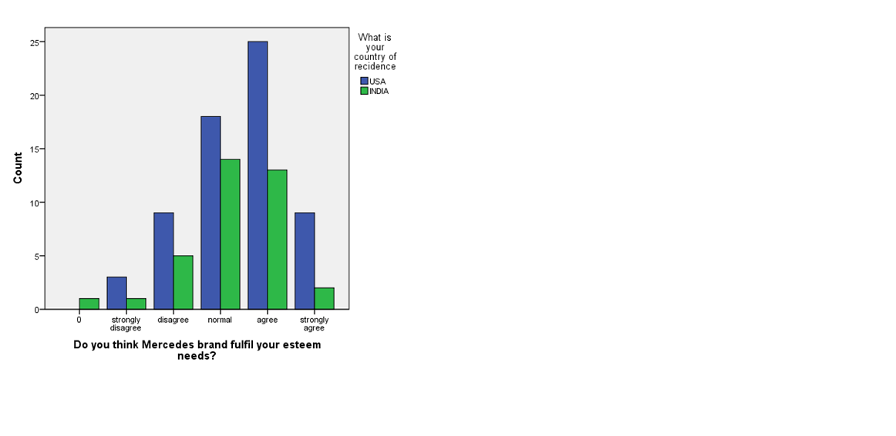

Figure 1Brand Value and Satisfaction

From the table and graphical display above it can be seen that 3 of the respondents from USA and 1 respondent from India strongly disagree with the fact that “Mercedes brand fulfil their esteem needs” in the similar manner total 15 people disagree with it and 32 of them given a neutral response, on the other hand 38 of the total respondents think that there esteem needs are fulfilled by this particular product and 11 of them strongly agrees with it.

|  |  |  |  |  |
| --- | --- | --- | --- | --- |
| Mercedes sedans are not necessity it’s a luxury product? * What is your country of residence  Cross tabulation | | | | |
| Count | | | | |
|  | | What is your country of residence | | Total |
| USA | INDIA |
| Mercedes sedans are not necessity it’s a luxury product? | strongly disagree | 1 | 1 | 2 |
| disagree | 13 | 5 | 18 |
| normal | 22 | 16 | 38 |
| agree | 25 | 11 | 36 |
| strongly agree | 3 | 3 | 6 |
| Total | | 64 | 36 | 100 |

Table 4Mercedes as a Luxury Brand

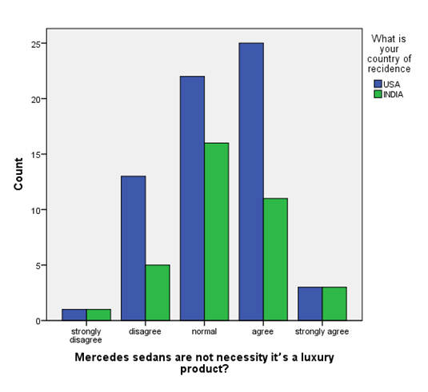

Figure 2Mercedes as a Luxury Brand

From the table and graphical display above it can be seen that 10 of the respondents from USA and 12 respondent from India strongly disagree with the fact that “Mercedes sedans are not necessity it’s a luxury product” in the similar manner total 25 people disagree with it and 32 of them given a neutral response, on the other hand 38 of the total respondents think that there esteem needs are fulfilled by this particular product and 51 of them strongly agrees with it.

|  |  |  |  |  |
| --- | --- | --- | --- | --- |
| Do you think the pricing of the Mercedes cars are truly value for money?  Cross tabulation | | | | |
| Count | | | | |
|  | | What is your country of residence | | Total |
| USA | INDIA |
| Do you think the pricing of the Mercedes cars are truly value for money? | strongly disagree | 3 | 2 | 5 |
| disagree | 6 | 7 | 13 |
| normal | 24 | 16 | 40 |
| agree | 25 | 9 | 34 |
| strongly agree | 6 | 2 | 8 |
| Total | | 64 | 36 | 100 |
|  | |  |  |  |

Table 5Value for Product

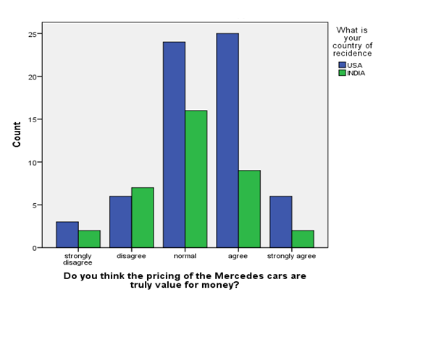

Figure 3Value for Money

From the table and graphical display above it can be seen that 10 of the respondents from USA and 12 respondent from India strongly disagree with the fact that “pricing of the Mercedes cars are truly value for money” in the similar manner total 25 people disagree with it and 32 of them given a neutral response, on the other hand 38 of the total respondents think that this particular product is true value for money and 51 of them strongly agrees with it.

|  |  |  |  |  |
| --- | --- | --- | --- | --- |
| Do you think mileage of your Mercedes car is an important feature?  Cross tabulation | | | | |
| Count | | | | |
|  | | What is your country of residence | | Total |
| USA | INDIA |
| Do you think mileage of your Mercedes car is an impotent feature? | strongly disagree | 5 | 1 | 6 |
| disagree | 4 | 4 | 8 |
| normal | 22 | 14 | 36 |
| agree | 23 | 10 | 33 |
| strongly agree | 10 | 7 | 17 |
| Total | | 64 | 36 | 100 |

Table 6 Mileage as an Important Feature

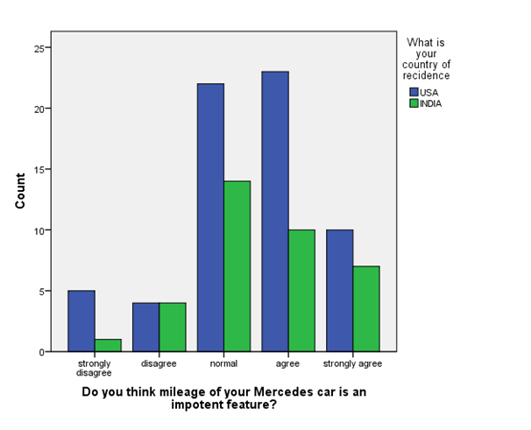

Figure 4Mileage as an Important Feature

|  |  |  |  |  |
| --- | --- | --- | --- | --- |
| Will you prefer leasing your Mercedes sedan for 5 years rather than buying it for life long  Cross tabulation | | | | |
| Count | | | | |
|  | | What is your country of residence | | Total |
| USA | INDIA |
| Will pricing of the Mercedes cars are truly value for money? | strongly disagree | 3 | 3 | 6 |
| disagree | 13 | 5 | 18 |
| normal | 17 | 12 | 29 |
| agree | 18 | 11 | 29 |
| strongly agree | 13 | 5 | 18 |
| Total | | 64 | 36 | 100 |

Table 7 Leasing your Mercedes

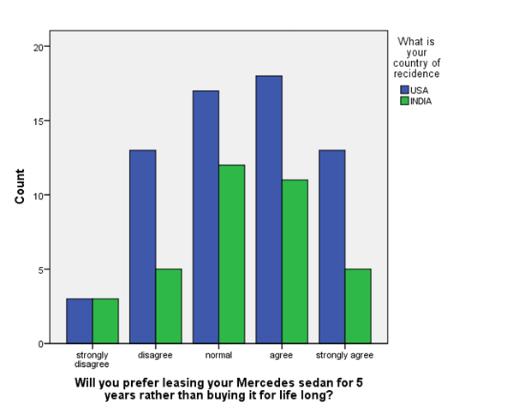

Figure 5Leasing your Mercedes

From the table and graphical display above it can be seen that 10 of the respondents from USA and 12 respondent from India strongly disagree with the fact that “pricing of the Mercedes cars are truly value for money’s a luxury product” in the similar manner total 25 people disagree with it and 32 of them given a neutral response, on the other hand 28 of the total respondents think that there esteem needs are fulfilled by this particular product and 51 of them strongly agrees with it.

|  |  |  |  |  |
| --- | --- | --- | --- | --- |
| Car financing planes played a vital role in making your buying decision while buying your Mercedes sedan?  Cross tabulation | | | | |
|  | | | | |
|  | | What is your country of residence | | Total |
| USA | INDIA |
| Car financing planes played a vital role in making your buying decision while buying your Mercedes sedan? | strongly disagree | 3 | 1 | 4 |
| disagree | 16 | 9 | 25 |
| normal | 26 | 12 | 38 |
| agree | 13 | 12 | 25 |
| strongly agree | 6 | 2 | 8 |
| Total | | 64 | 36 | 100 |

Table 8Financial Planes Vs Consumer Behaviour

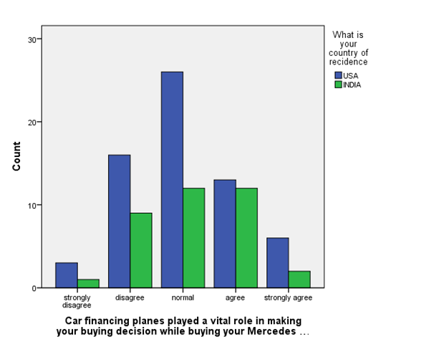

Figure 6 Financial Planes Vs Consumer Behaviour

Anova is a mean comparison process or technique which compares the above questionnaire depending upon a class variable and indicates that there is any significant mean difference or not and eventually we can test the stated hypothesis and its validity.

|  |  |  |  |  |  |  |
| --- | --- | --- | --- | --- | --- | --- |
| ANOVA | | | | | | |
|  | | Sum of Squares | df | Mean Square | F | Sig. |
| Do you think Mercedes brand fulfil your esteem needs? | Between Groups | 1.361 | 1 | 1.361 | 1.242 | .268 |
| Within Groups | 107.389 | 98 | 1.096 |  |  |
| Total | 108.750 | 99 |  |  |  |
| Mercedes sedans are not necessity it’s a luxury product? | Between Groups | .018 | 1 | .018 | .022 | .882 |
| Within Groups | 79.222 | 98 | .808 |  |  |
| Total | 79.240 | 99 |  |  |  |
| Do you think the pricing of the Mercedes cars are truly value for money? | Between Groups | 2.587 | 1 | 2.587 | 2.844 | .095 |
| Within Groups | 89.123 | 98 | .909 |  |  |
| Total | 91.710 | 99 |  |  |  |
| Do you think mileage of your Mercedes car is an impotent feature? | Between Groups | .051 | 1 | .051 | .045 | .833 |
| Within Groups | 110.859 | 98 | 1.131 |  |  |
| Total | 110.910 | 99 |  |  |  |
| Will you prefer leasing your Mercedes sedan for 5 years rather than buying it for life long? | Between Groups | .293 | 1 | .293 | .220 | .640 |
| Within Groups | 130.457 | 98 | 1.331 |  |  |
| Total | 130.750 | 99 |  |  |  |
| Car financing planes played a vital role in making your buying decision while buying your Mercedes sedan? | Between Groups | .195 | 1 | .195 | .197 | .658 |
| Within Groups | 97.165 | 98 | .991 |  |  |
| Total | 97.360 | 99 |  |  |  |

Table 9 ANOVA

From the table above it can be seen that the between group F values are less than the standard tabulated F value for 98 degrees of freedom and 95% significant level . Hence we can conclude that there is no significant difference between the opinions among Indian and American Mercedes Benz users.

## 4.4 Regression analysis:

Regression analysis is a statistical process which indicates the relationship between independent and dependent variables. In the tables below the researcher have done a regression analysis by taking “Do you think Mercedes brand fulfil your esteem needs?” as the dependent and income, age, place of residence and profession as independent variables.

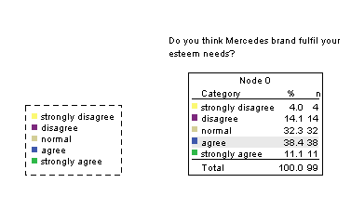

Regression Analysis:

|  |  |  |  |  |
| --- | --- | --- | --- | --- |
| Spearman’s Model | | | | |
| Model | R | R Square | Adjusted R Square | Std. Error of the Estimate |
| 1 | .246a | .061 | .021 | 1.037 |

Table 10 Spearman Model

|  |
| --- |
| a. Predictors: (Constant), What is your profession , What is your country of residence , What is your age group , What is your income group |
| b. Dependent Variable: Do you think Mercedes brand fulfil your esteem needs? |

|  |  |  |  |  |  |  |
| --- | --- | --- | --- | --- | --- | --- |
| ANOVAa | | | | | | |
| Model | | Sum of Squares | df | Mean Square | F | Sig. |
| 1 | Regression | 6.587 | 4 | 1.647 | 1.531 | .199b |
| Residual | 102.163 | 95 | 1.075 |  |  |
| Total | 108.750 | 99 |  |  |  |

Table 11 Anova- Brand Vs Need Fulfilment

|  |
| --- |
| a. Dependent Variable: Do you think Mercedes brand fulfil your esteem needs? |
| b. Predictors: (Constant), What is your profession , What is your country of residence , What is your age group , What is your income group |

|  |  |  |  |  |  |
| --- | --- | --- | --- | --- | --- |
| Coefficients | | | | | |
| Model | | Unstandardized Coefficients | | Standardized Coefficients | t |
| B | Std. Error | Beta |
| 1 | (Constant) | 3.949 | .641 |  | 6.158 |
| What is your country of residence | -.259 | .217 | -.119 | -1.195 |
| What is your age group | -.127 | .103 | -.123 | -1.234 |
| What is your income group | -.090 | .096 | -.094 | -.936 |
| What is your profession | .138 | .099 | .140 | 1.390 |

Table 12 Coefficients-1

|  |  |  |
| --- | --- | --- |
| Coefficients | | |
| Model | | Sig. |
|
| 1 | (Constant) | .000 |
| What is your country of residence | .235 |
| What is your age group | .220 |
| What is your income group | .352 |
| What is your profession | .168 |

Table 13 Coefficients-2

|  |
| --- |
| a. Dependent Variable: Do you think Mercedes brand fulfil your esteem needs? |

|  |  |  |  |  |  |
| --- | --- | --- | --- | --- | --- |
| Residuals Statistics | | | | | |
|  | Minimum | Maximum | Mean | Std. Deviation | N |
| Predicted Value | 2.35 | 3.87 | 3.35 | .258 | 100 |
| Residual | -3.056 | 2.113 | .000 | 1.016 | 100 |
| Std. Predicted Value | -3.887 | 2.017 | .000 | 1.000 | 100 |
| Std. Residual | -2.947 | 2.037 | .000 | .980 | 100 |

Table 14 Residual-1

|  |
| --- |
| a. Dependent Variable: Do you think Mercedes brand fulfil your esteem needs? |

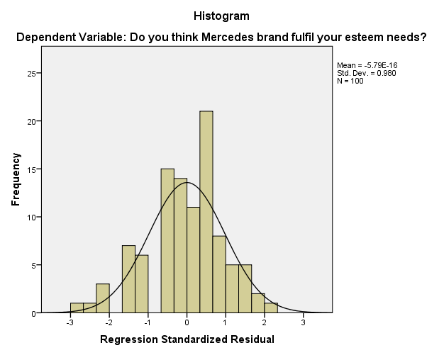

Figure 7 Dependent-1

From the table above it can be seen that the r-square value is .062 which indicates that the model is not very good and there is only 6.2% relationship between the dependent and the independent variables. Hence it can be concluded that the opinion difference is not only dependent upon the demographic factors , there are some other factors which influence the users thought process and opinion about this particular car under consideration.

## 4.5 Qualitative Analysis:

* How do you think that the marketing strategy of Mercedes Benz helps to improve itself in US?

The marketing strategy of Mercedes Benz helps a lot in increasing its demand in USA It includes porters five model. Those are the parameters of price, concepts related to product, ideas related to place and finally the concepts related to people. In Unites States, the brand becomes very popular and with the help of marketing steps which are very effective its growth is increasing rapidly. The products are being fascinated to a much higher level so that it becomes very much attractive to the people or customers who will go to buy the product. The customer cares are being enabled to deliver the services in a very delightful way. The processing systems are very much efficient and effective enough so the customers will be benefited. The employees are very skilled and qualified. Through the process of penetration which consists of marketing in a very effective way, its expansion is occurred which ultimately increases production and consumption level to a degree.

* How the strategies of marketing help its expansion in India?

The managers of the organization In India stated that, the strategies of marketing helps a lot to increase its demand regarding buying the vehicle named as Mercedes Benz. But it has been noticed well that the rate of the consumption of Mercedes Benz is not so high as compared to United States of America. It is due to the reason that people of India is not so renowned for drawing handsome amount of salary. In contrast in United States, most of the people are very well known for drawing the amount of salary which is economically healthy and very strong. The values of economy of United States worth a lot compare to India. But in India it matters to the normal customers great. So the product is being bought by very rich people who have that capability to buy the vehicle. But all the concerned customers who are using the product are very satisfied with all kinds of amenities provided by the company. So now the consumption rate has been increased to some extent.

* What are the services provided by Mercedes Benz?

In respect to the company it has been quite noticed or viewed that the organization provides very well services to the customers who are utilising the product. Many service centres are available both in perspective to India and the country named as United States. Those service centres are very efficient in delivering very quality services. Many retail shops are available for the delivery of products which are concerned in this topic. Customers when they visit or come to any of the shops which are purposed for retailing, they need to enrol their names and the orders have been taken by the company. Then checking all the required documents the orders are being processed accordingly. Therefore with this so well mannered policy the customers use to receive the demanded or desired product very quickly and in a much organised way. All the service centres or customer cares are connected in much good manner hence they are known for providing the services with full efficiency. In terms of the used cars if any faults are being discovered by any people of being faced by any consumers then that particular fault is being serviced in much effective manner. That time also there remains a good ordering system. Various orders are being generated according to the queue. Then those orders are being processed accordingly by the manufacturers who are solely responsible for spares and henceforth the parts which have been crashed are being repaired. Just the duties of the customers are only to bring the vehicle with faults which are being suffered to the correct service centres which are responsible for providing well mannered help.

* What are the marketing standards of Marketing Benz?

The standards of the marketing are being adhered, when the preparation of 3 tier communication related to marketing are done along with the maintenance regarding the integration of Mercedes Benz and all the eligibility issues are being ensured for the purpose of eligibility in relative to Mercedes Benz of United States of America. There are various violations relative to the 1st category standards which are being harmful to all kinds of images of brand of Mercedes Benz. The Mercedes Benz of the country which is being named as United States maintains a faithful environment so that everything can be possible in regards of the market of Mercedes Benz dealerships and its various products. The least price which has been advertised in respect to vehicles is being available for the period of offerings which is being considered as equal or it may phrased greater than price which has been fixed for the month of current time period.

# 4.6 Discussion

The above data analysis chapter is completed with the help of SPSS. All the analytical tools and statistical techniques that are used in this chapter helps the researcher and the readers to get a clear idea about the performance and marketing strategies of Mercedes Benz. The descriptive statistics helps to understand the standard deviation, max and min value. The crosstab analysis helps in comparing different dependent and independent variables to obtain accurate values and the Annova testing helps in comparing the variables and figures out the significant difference which helps then researcher to determine the hypothesis of the entire research study. The qualitative analysis reflects the feedbacks of the manager of Mercedes Benz that has helped the researcher and the readers to understand several problems and has also provided solutions for those problems. Hence, we can easily conclude that the entire data analysis section has helped the research study to provide an appropriate analysis.

# Chapter 5.0: Conclusions and Recommendations

### 5.1 Introduction

This whole chapter is fully concerned on the various strategies of marketing in respect to the automobile company named as Mercedes Benz and at the same time to determine the difference of styles of marketing in both the countries India and in United States. The process or system of various strategies of marketing helps the organisation which is Mercedes Benz here, to give more emphasis on the various resources for the purpose of increase of sales which in turn is very much helpful for achieving the advantage which is sustainable (Menard, 2002). The concept of market strategy enables in choosing segment of market which has been targeted by the organisation. It becomes much more effective whenever the strategy of the organisation is being considered as the integral component. This is by which customers are being engaged by the organisations thereby protecting themselves in area of market field (Meredith, 1998). The ideas of strategies relative to marketing are very interactive and dynamic in nature. Various influencing factors are there which influences the business in individual perspective to describe the situation which is very unique in nature. With the help of these unique strategies related to marketing, the organisation is able to expand its business over the whole world so that human satisfaction can be met which will going to generate the specialized field.

## 5.2 Objectives Linking:

In this particular section, it is the main job of researcher to generate a good link among the experiences which have been gathered practically and the knowledge which has been gathered theoretically by taking the help from the review which has been gathered from literature. Based on the alignment in theoretical respect and experiences that have been gathered practically the rate of the success in terms to the study of dissertation can be easily determined.

Objective 1: Evaluation of market strategies

The consumers which consist of 56% includes the plan for the purpose of service in terms of complimentary or in prepaid and it is being stated that the service is being continued at the places of dealership after the plan has been expired. It has been noticed that 1out of 4 in the country United States the owners of the vehicle consists of dealer where it exists the plan for the service which is free or prepaid. The figure which consists of62% utilise plan for the purpose of maintaining all the activities which are being closely related with all the dealers. The servicers who have been treated as the people for next generation and their age range is below 35 years are being considered to be more planned and organised rather than people or servicers who are above the age group of 35 years and the figure consists of 18%. The servicers who belong to the group of next generation are much more involved in the field of maintenance and this is being done keeping the plan in mind and the measure consists of values 72% compared to the servicers who are falling under the age group of 61%. The owners of the vehicle known as Mercedes Benz who are considered to be new person are renowned for switching purpose of the various brands of vehicle so as they can be able to purchase vehicle which is of latest brand. The figure of 33% tells that the vehicles which are from brand made in previously are not offering as compared to the vehicles which are offering many latest unique features so the trend of buying the latest vehicles is increasing gradually. Other dissatisfaction reasons are sometimes it is being noticed that the vehicles becomes too much costly for the purpose of owning or maintenance. Most of the vehicles are available with lots of problems. Much of the resale values are not being retained in the brand of vehicles which are known to be made previously.

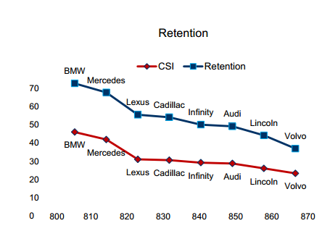

Figure 8 Resale value

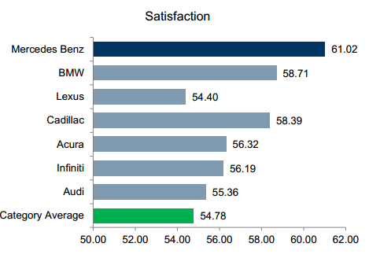

Figure 9 Level of Satisfaction

http://www.pensa.org.br/anexos/biblioteca/2032007153540_TheEconomicsofHybridOrganizations.pdf [Accessed: 2013/12/03].

Objective 2: To evaluate differences among marketing of Mercedes with respect to India and in respect to United States

The marketing strategies of Mercedes Benz in India consists of all the terms like place, the terms of product, the concept of promotion, processes and finally the product. It is very well established and positioned with the idea of effective marketing. The products are being fascinated with lots of astonishing and outstanding features. Though the retail shops regarding the delivery of vehicle named as Mercedes Benz are comparatively low in India but still it is being noticed that some of the great level of people who are handling with crore of money are likely to buy the vehicle. Their service is also very well provided with delightful and responsible service centres. Their customer cares are very much efficient and effective. All the retail shops are good at networking so that customers do not face any problems. They employ very skilful and knowledgeable employees having good technical knowledge. They are very much motivated with carrying the penetration facility in terms of their market in a very effective way. The question that is being asked to the customers who are buying the vehicle in respect to the country named as India is whether the consumers are really aware or worried about the worthiness of the price of the vehicle. The answer comes which consists of 16% gives normal feedback and the value with 9% provides the answer of agreeing with the fact. 7% of the values disagrees along with question or provides reply against the fact. In terms of strongly agreeing with idea of whether the price value really worth to buying vehicle, the value is just 2%.In terms of United States the numbers of retail shops is much more compared to India. Their customer cares are also very well organised and connected. Thereby they provide great service. Here more customers are involved in buying the vehicle. In terms of the economic field the United States price of money is less and maximum amount of people are well furnished and draw handsome amount of salary compared to which the price of the vehicle seems to be very low. The same question has been asked to the customers of United States regarding the fact that whether the pricing value really matters to them or not in perspective to Mercedes Benz. 24% of the values remain normal and 25% simply agree with the fact but the values of strongly disagreeing the matter consists of 3% which is much more than India.

Objective 3: Evaluation of reason in terms of difference of strategies of marketing

Mercedes Benz in the United States in earlier days were centred It was mainly centred because it contained several precious and luxurious values. But as days are more advancing, the level of competition is increasing day by day. The competition level is increasing in terms of luxury and standards of the vehicle industry in perspective of other car, the attitude of the normal customers or consumers of United States are shifting or changing gradually. So to draw more and more attention regarding buying of Mercedes Benz, the organisation improves its strategies of marketing in a much more quality level and advance level. So the strategies are now becoming much more friendly and interactive so that it will ultimately help the consumers to implement the vehicle in a flexible way. The market of Mercedes Benz is expanding and it is connected with market of huge target directly. To deliver the values of the customer in a superior way so it expands its business level to much greater height and also increases thereby the line up for the products.

## 5.3 Recommendations

From this above research, it is being ensured that the manufacturer consisting of single vehicle, the manufacturers who are solely responsible for the preparation of the vehicle with the raw materials are going to outsource the full responsibilities to the dealers or intermediate retailers for the purpose of delivery from their several outlets. These responsibilities include the scale of economics and the effectiveness of selling the vehicles by all the retailers. The manufacturers’ first priority is to take orders from the various customers. Then after that they are trying to meet the needs of the customers by preparing the vehicles in that order. The manufacturers are then considered to give the responsibility of preparation to all the retailers for the purpose of delivery.

Those who are engaged in spares manufacturing they are responsible for taking the orders of those used cars which have already been used. The spares manufacturers also take the responsibility of providing servicing which are required after sales. Those customers who are facing lot of problems regarding their products, the spares manufacturers provide immense support to them along with that customer care located in various places are engaged in delivering immense help and servicing by giving them immense support with full efficiency. This is being done in a very effective way. The orders have been prepared by the manufacturers who are engaged in manufacturing the spare parts. The services are being delivered accordingly to the consumers thereby repairing the crashed parts of the vehicle. Then the crash parts are being repaired.

Now it is the full responsibility of the consumers to bring the problems to the people who are mainly busy in providing the services. Those who are new consumers can go to the retail shop directly for buying the new cars of Mercedes Benz. They are required to wait for the preparation purpose of orders and then when their turn will come they are being delivered with the products. If any customers are having problems with the cars they have already utilised then they are to bring those cars to spares manufacturers. There also the same thing is going to happen which means at first the orders are to be built and the cars are being serviced accordingly. If they are facing any sorts of problems regarding any other issues they are to get the after services from the customer care or from any other service centres. On the report which has been prepared annually the sales part as a whole round about marking of 1.5 million dollar. Various sorts of market segments are developing gradually and thereby the segments responsible for luxurious purpose are also growing at a huge rate. Therefore it is being stated or noticed that the factor for growth or the development varies from end of the market at the respect of bottom level and that of the top level.

Nowadays the demand for this kind of luxurious vehicles like the organisation who are solely responsible for delivery of vehicles named as Mercedes Benz is increasing day by day. The obsession which has the utility for sports is responsible for bursting and this has been reported from several analysts. The statement of the annual growth in respect to luxurious vehicles like Mercedes Benz has reached to 10 percent. Each and every year this same thing is averaged to the figure closely to 10%. For this purpose, the competition of the market segment is being increased. There are lots of factors which are considered to be mainly responsible for the growth. As the people are aging gradually it is being seemed those who are above 55 years are very much free for all kinds of businesses which are financially connected and henceforth the economic condition remains at healthy position? So it becomes very much easy for all the people in Unites States to afford for this expensive vehicle compared to Indian people. As the condition of economy is not enough well in India it can’t be possible for many of them to afford for such costly vehicle.

# References

Agarwal, K.C. (2001), "Urban Mass Transportation in India," Proceedings of the World Conference on Transport Research, Rotterdam, 1977.

Automan, (1991).Association of Indian Automobile Manufacturers.

Babbie, E.R., (2009). The Practice of Social Research.12th edition. Wadsworth Publishing: UK

Bacher, G., (2010), Inductive and deductive research, 3rd Ed. Webook: Australia.

Banerjee, S., (2006), Research approaches, 7th Ed. Ace books: Sydney.

Barr, P.S., Stimpert, J.L. and Huff, A.S. (1992) “Cognitive Change, Strategic Action, and Organizational Renewal”, Strategic Management Journal, 13 (Special Issue), pp. 15-36.

Creswell, J. W. (2008). Educational Research: Planning, conducting, and evaluating quantitative and qualitative research. 3rd ed. Pearson: Upper Saddle River

Denzin, N. K., & Lincoln, Y. S. (2000).Handbook of qualitative research. 2nd ed. Thousand Oaks, CA

Douglas, G., (1998). Research methodology: a new approach. 2nd ED. Academic Press: UK.

Feng, Y., Xiao, B., (2004), Integration of pricing and capacity allocation for perishable products, Preprint, Chinese University of Hong Kong

Fifield, P., (2007). Marketing strategy: the difference between marketing and markets. 4th Ed. Penguin: London.

Flanagan, J. C. (1998). A research approach to improving our quality of life.*American Psychologist*, 33 (2), p. 138.

Graham, H., (2008). Marketing strategy and competitive positioning. 7th Ed. Daw Books: Germany.

Guillemin, M. and Gillam, L. (2004).Ethics, reflexivity, and “ethically important moments” in research.*Qualitative inquiry*, 10 (2), pp. 261--280.

Hague, N., (2000), Data collection and sampling, 2nd Ed. BBC Books: London.

Handlechner, M., (2006), Research philosophy, 6th Ed. Atlas press: Holland.

Hawkins, D., (2006), Research Methodology, 7th Ed. Faber and Faber: London.

Hirschman, E. C. (2004). Humanistic inquiry in marketing research: philosophy, method, and criteria. *Journal of marketing Research*, pp. 237--249.

Holliday, A. R. (2007). Doing and Writing Qualitative Research, 2nd Edition. Sage Publications: London.

Hoyer, W. & Brown, S. (1990), ‘Effects of brand awareness on choice for a common repeat purchase product’, Journal of Consumer Research, Vol.17, No.2.

Hutt, M.D., Walker, B.A. and Frankwick, G.L. (1995) “Hurdle the Cross-Functional Barriers to Strategic Change”, Sloan Management Review, 36 (3), pp. 22-30.

Iacobucci, D., Henderson, G., Marcati, A. & Chang, J. (1996), ‘Network analyses of brand switching behaviour’, Journal of Research in Marketing, Vol.13.

Kassarjian, H. (1971), ‘Personality and Consumer Behaviour: A Review’, Journal of Marketing Research, November.

Kleywegt, A. J. (2001) An optimal control problem of dynamic pricing. Working paper, Georgia Institute of Technology, Atlanta, GA.

Kossowski, A., (2011) Strategic management: Porter’s model of generic competitive advantage strategies-theory and analysis, Druck and Bindung: Norderstedt Germany.

Marquardt, S (1994).. ‘BMW buys Rover; Britain goes ballistic’, Automotive Industries, March

Menard, C. (2002). The Economics of Hybrid Organizations. Presidential Address, International Society for New Institutional Economics: University of Paris, France, September 29 [On-Line]. Available:http://www.pensa.org.br/anexos/biblioteca/2032007153540_TheEconomicsofHybridOrganizations.pdf [Accessed: 2008/12/03].

"Mercedes launches B Class diesel variant in India". Biggaddi.com. Retrieved (2013)

"Mercedes to invest €700 m in Chennai plant". Economic Times (Economic Times), (2009)-08-04. Retrieved 28 May 2011.

"Mercedes-Benz India - New Car Models - Mercedes-Benz Model Overview".Mercedes-benz.co.in. Retrieved 2011-04-18.

"Mercedes-Benz India Record 94% Sales Growth - CarWale News".Carwale.com. (2010)-07-07. Retrieved (2011)-04-18.

Meredith, J. (1998). Building operations management theory through case and field research. Journal of Operations Management, 16(4): 441-454

Morris, M. & Holman, J. (1988), ‘Source Loyalty in Organizational Markets: A Dyadic Perspective’, Journal of Business Research, Vol.16 (March), pp.117-131.

Motor Industry and Research Association (1997), The Emerging Asian Auto Markets 1996, UK: Hobbs the Printers.

Motor Industry and Research Association (1997), The Emerging Asian Auto Markets 1996, UK: Hobbs the Printers, pp.325-333.

MurryJr, J. W. and Hammons, J. O. (1995). Delphi: A Versatile Methodology for Conducting Qualitative Research. *Review of Higher Education*, 18 (4), pp. 423--36.

Sanyanusin, P. (1994), An Analysis of Demand for Passenger car in India, Sage: London

Sarna, A.C. (2003), "Importance of Nonmotorized Transport in India," Transportation Research Record, No. 1294.

Scheele, N. (1995), ‘The luxury car sector of the future and Jaguar’s part in it’ in D. Stirley& K. Read (ed.) MIRA 1946-1996 Golden Jubilee: Fifty Years of Excellence. Warwickshire: MIRA, p.190

Urban, G. & Hauser, J. (1980), Design and Marketing of New Products, New Jersey: Prentice Hall.

Yaping, C. and Jun, Y. (2002). Mercedes-Benz Car Gripped Up in India--A Case of Cross-Cultural and National Marketing. *Journal of Euro marketing*, 12 (2), pp. 71--86.